1. Brief Description of what topic or technology you are concentrating on: Configuring static routing tables.

2. Topology screen capture:

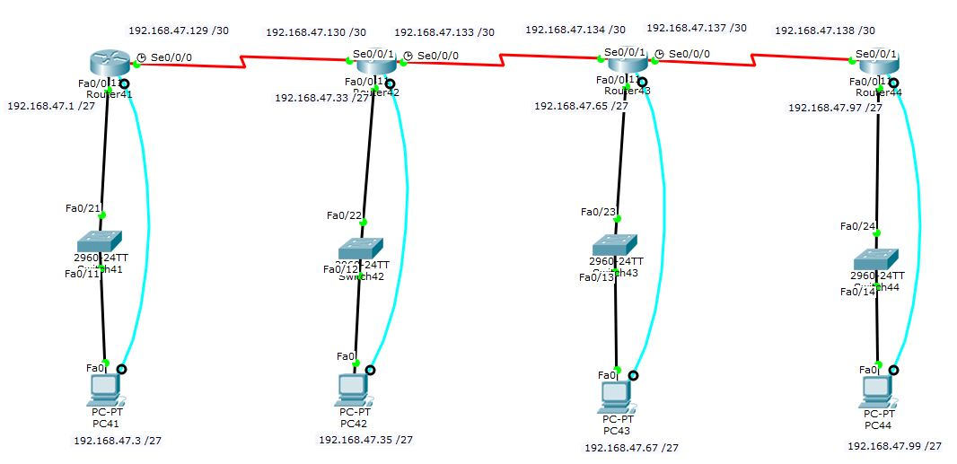

3. Table of Command Syntax and the associated description:

|  |  |
| --- | --- |
| Command | Description |
| Ip route [network] [subnetmask] [closest hop] | Add route to static routing table |
| Show ip route | Show the routing table of the router |

4. Verification (ie: ping, tracert, traceroute tools and output)

PC1:

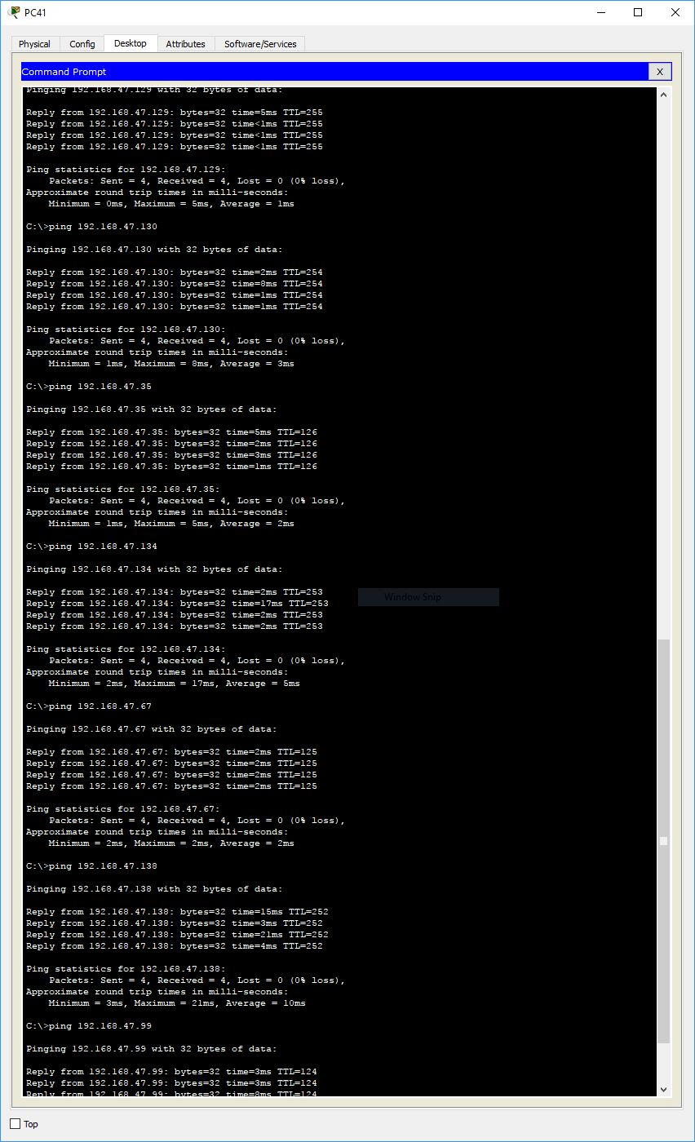

PC2:

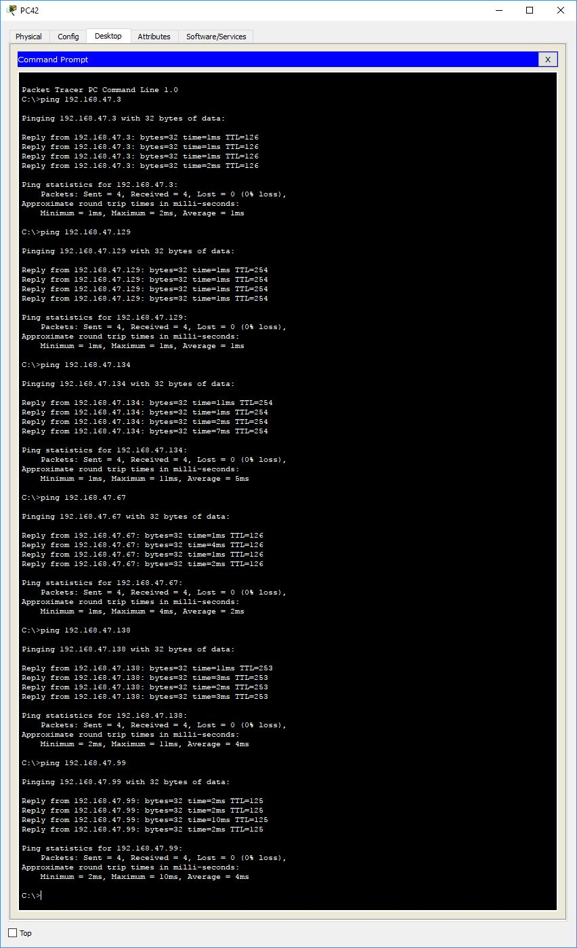

PC3:

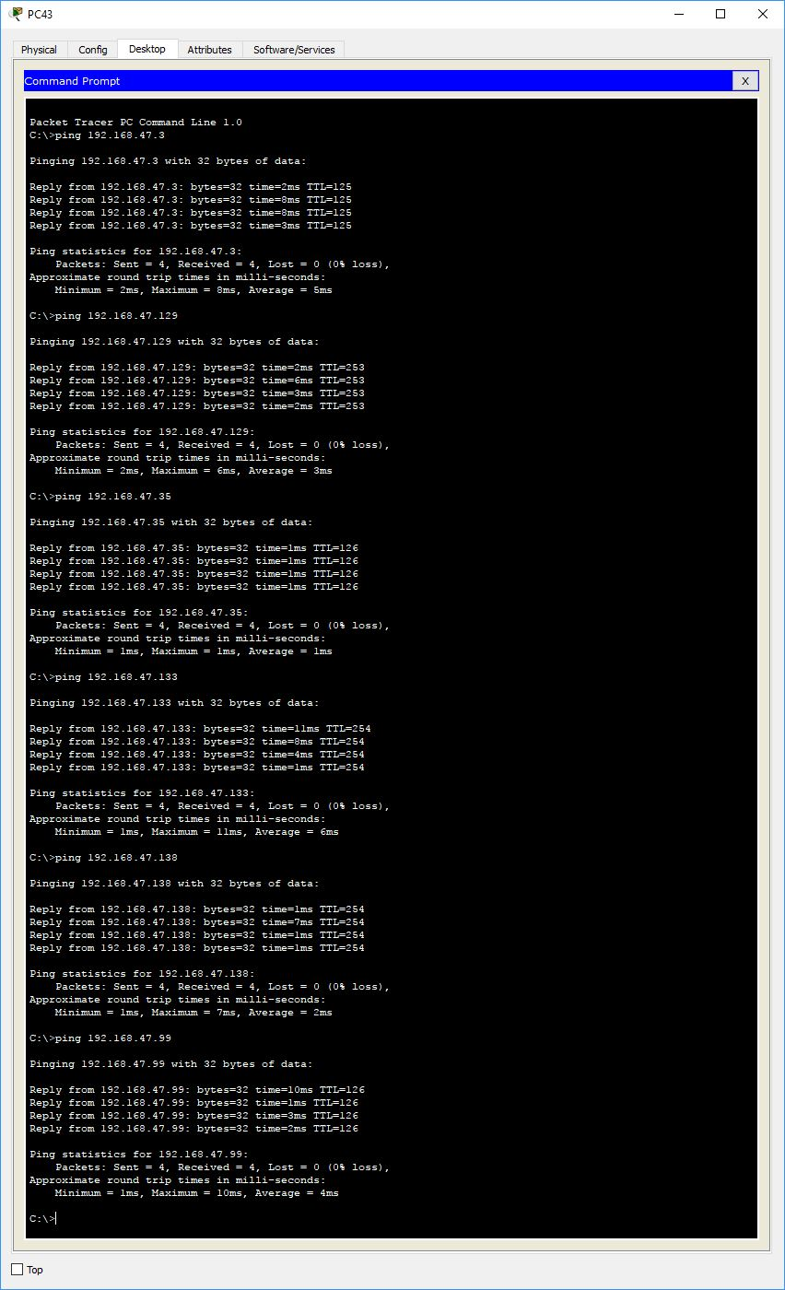

PC4:

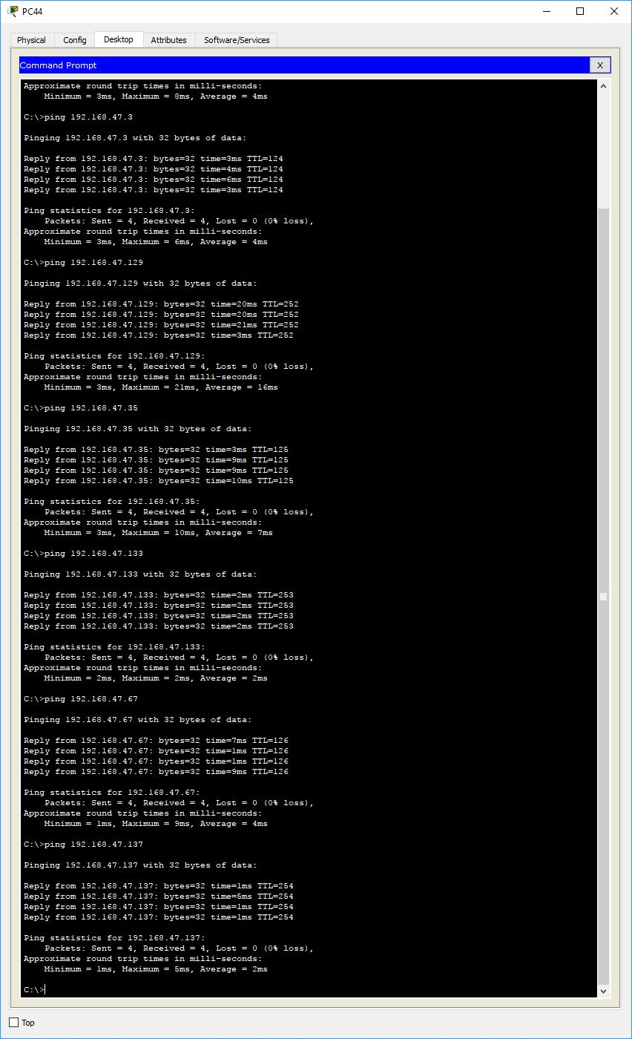

5. Results / Outcomes (ie: what worked?, what didn't?):

Everything seemed to work. All the devices were able to ping each other.